**FestMan Stores Financial Analysis Report (2013–2014)**

**Executive Summary**  
This report analyzes the sales performance of FestMan Stores across fiscal years 2013 and 2014. Using time intelligence tools in Power BI, we examined these Key Performance Indicators (KPI): **sales, number of orders, profit, profit margin, and number of discounts**. Key findings indicate a significant sales increase in Q4 2014 driven by our **Channel Partners**.

**Objective**

The primary objective of this report is to evaluate sales performance across two fiscal years to identify growth patterns and potential areas of improvement for strategic planning.

**Analysis of Key Performance Indicators**

For our report we identified five **KPIs** for analysis**: sales, number of orders, profit margin,** and **number of discounts**.

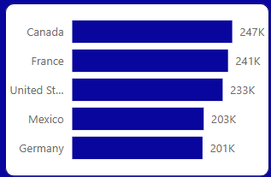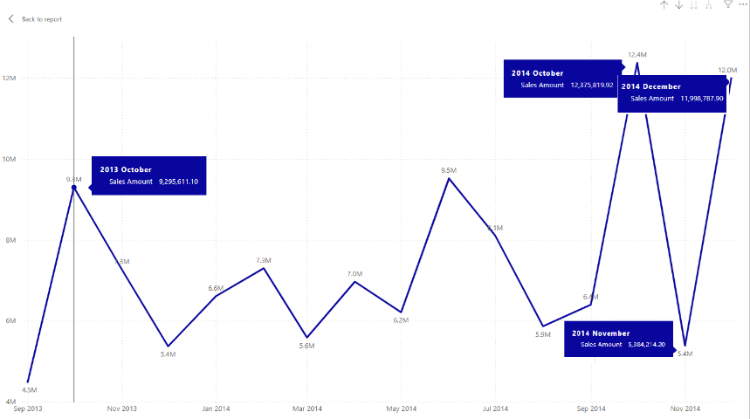Based on our time intelligence analysis, our **Sales** saw an increase of 249% between 2013 and 2014. October 2013, saw the highest number of sales at $9,295,611 for 2013. October was also month with the highest sales in 2014 at $12,375,819. There was a dip in November at $5,384,214 but a substantial rise in sales in December at $11,998,787. The spring and summer months of 2014 also saw massive dips and could provide opportunities to improve sales margins.

Analysis of **number of orders** between 2013 and 2014 saw an increase of 225%. Of the countries we sell our products to, the top 3 are Canada at 247,427, France at 240,932, and the United States at 232,628 in 2014.

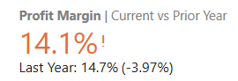Analysis of **profit** and **profit margin** gave interesting insights. Overall profits were up 235% from 2013; however, our profit margin was down 4%. Countries like the United States and Mexico saw an increase in profit margin while Canada, France, and Germany each saw an overall decrease in profit margin. France saw the largest profit margin decrease at -2% while the United States saw the largest profit margin increase at 14%. Of our market segments, Enterprise was our least performing and only segment with negative growth at -3%

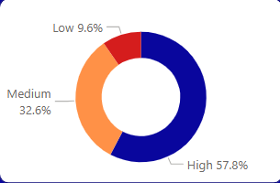Our **Discounts** were up 229% from 2013 from $2,145,531 to $7,059717 for 2014. Those companies in the high band tier reported at 58% with those in the low tier band at 9.6%.

**Category/Department Performance**

**Top Categories 2014:**

* Paseo was our top performing product bringing $33,011,144 in sales.
* 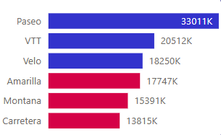VTT was our second highest performing product bringing $20,511,921 in sales.
* Velo was our third highest performing product bringing $18,250,059 in sales.

**Bottom categories 2014:**

* Carretera was our lowest selling product bringing $13,815,308 in sales.
* Montana was our second lowest selling product bringing $15,390,802 in sales.
* Amarilla was our third highest selling product bringing $17,747,116 in sales.

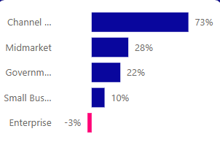Overall our different market segments brough a profit with the exception of our enterprise market with a loss of 3% in profit margin 2014. Our highest performing market segment was Channel with a growth of 73%.

**Conclusion & Recommendations**  
Analysis shows that our overall sales trajectory is positive; however, the data also showed a small decline in profit margin.

**Recommendations for an increase in profit margin:**

* Expand top-performing segments and products (Channel, Midmarket, Government | Paseo, VTT, Velo)
* Reassess product strategy for underperforming segments (Small Business, Enterprise)
* Explore opportunities for our European Market.
* Reassess our discounts for an opportunity for a higher profit margin.
* Research manufacturing to see if costs can be lowered to increase profit margin without increasing product price.
* Launch promotions for both Spring and Fall to offset seasonal dips.